How to Make PowerPoint Presentations
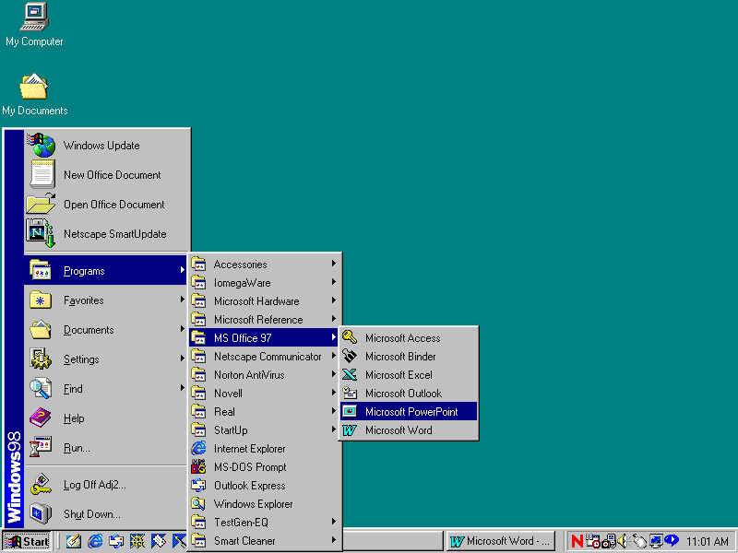
1. Hit Start>Programs>MS Office 97>MS PowerPoint

2. Hit Template>OK

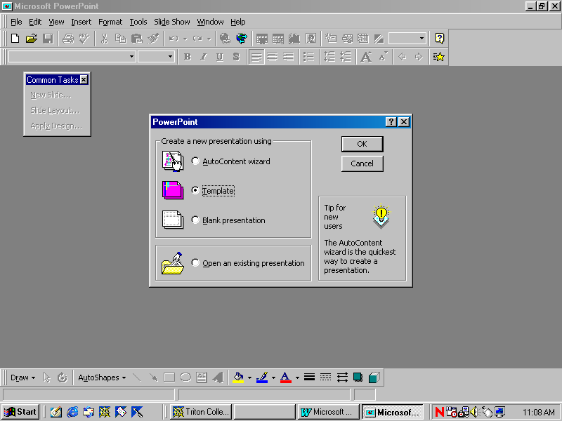

3. Select Presentation Designs Tab

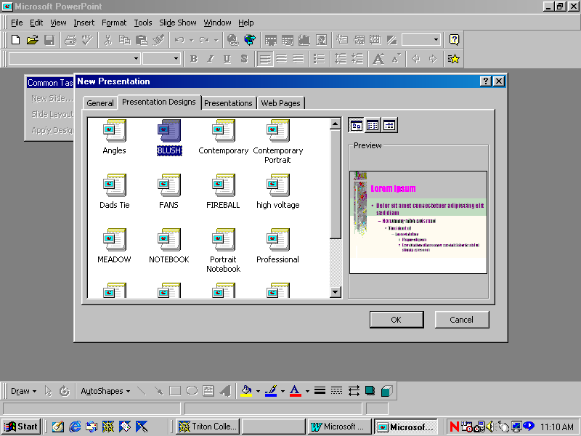

4. Pick any background that you like and click O. K.

- Choose the Slide Frame in the Upper Left-hand Corner> Click O. K.
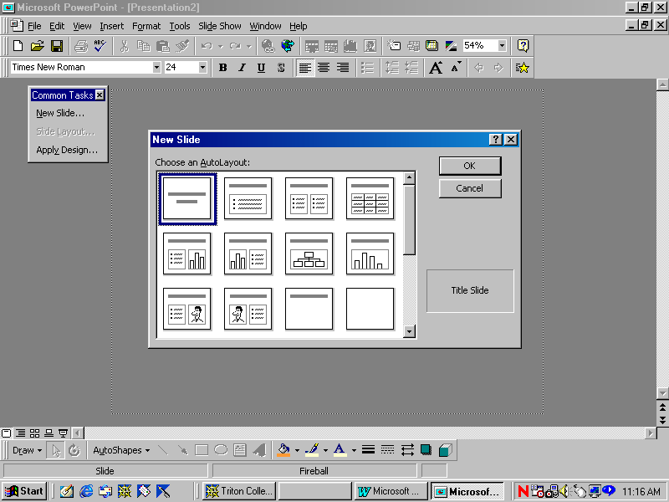

6. Click where it says, “Click to Add Title”
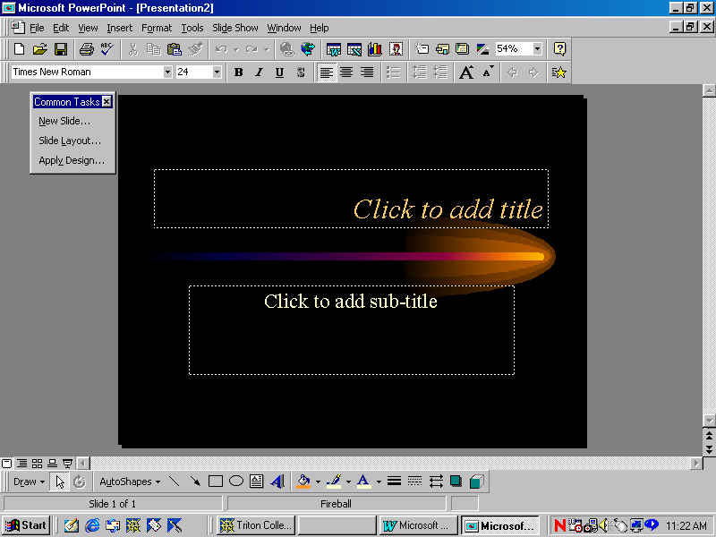

7. Type> “My Summer Vacation”

Click where it says Click to Add sub-title A) Hit the “Bullet” Button. Make sure it is “Left Justified”

- Type:
- “My friend went to the beach” Hit Enter.
- Type “My other friend went camping” Hit Enter.
- Type, “I went to Speech Class” Do NOT Hit Enter

- On the bottom of the screen, on the left hand side there is a symbol that looks like this
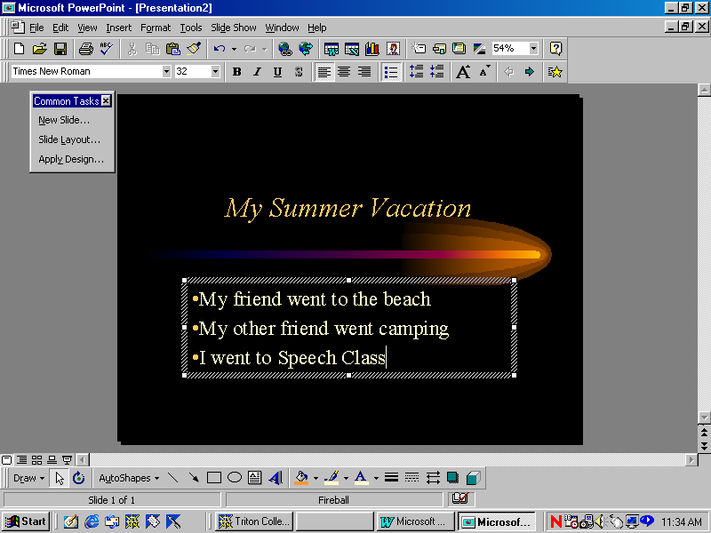
(It is two boxes on the top and two boxes on the bottom. It is called the Slide Sorter Tray)

Click on it

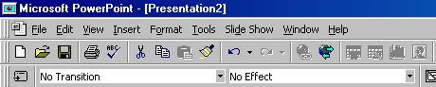
- On the top of the screen, there are two boxes (“No Transition” and “No Effect”). Hit the arrow to the right of the No Effect and pick the one you like (Of course you don’t KNOW what you like, because you can’t see them).

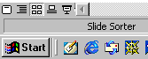
- On the bottom left-hand corner of the screen, hit the button called SLIDE SHOW. It has two buttons to the right of the Slide View Button.
12. Now, when you hit the SPACE Bar or the MOUSE Button, your Bullets will FLY on! Hit Escape to return to the Slide Sorter View

13. Hit the SLIDE VIEW button. Go to INSERT (top of the screen)>NEW SLIDE

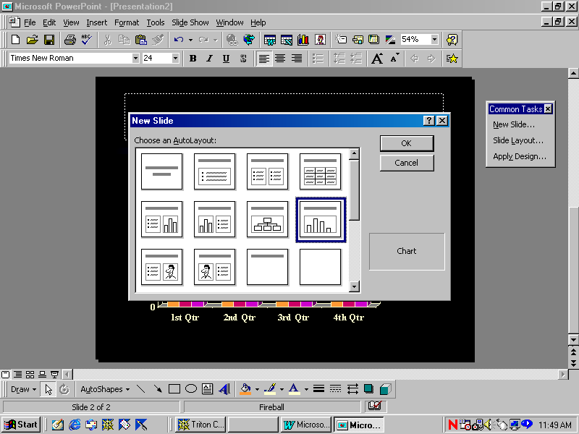
- Hit the icon that looks like this:

- Double Click where it is indicated. Go into the cells and change that information anyway you like.

- Go back to the SLIDE SORTER view (see Step 9). You will now see your two slides.

- Change the “No Transition” box (by pressing on the arrow on the right hand side) to whatever you like. (See Step 10).

- Make sure your First slide is selected. Then, go to the Slide Show (Step 11) and hit the space bar. The slides will change with your transitions. Hit Escape.

- Hit the SLIDE VIEW button. Go to INSERT (top of the screen)>NEW SLIDE. Insert the slide in the upper left-hand corner. (This is a repeat to Step 13).

- In the Box on the top, type “Pictures from my Vacation”

- Hit Insert>Pictures>Clipart
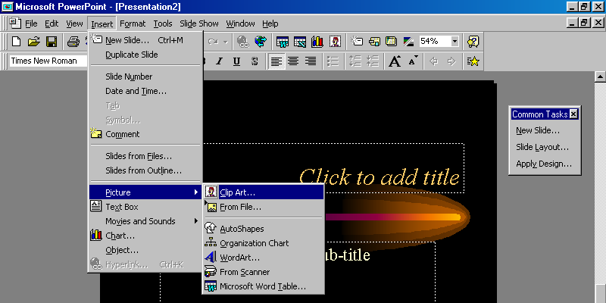
22. Find one you like and hit Insert

- Go back to the SLIDE SORTER and add a transition.

- Go to Slide View. Hit Insert>New Slide and select a Blank Slide

- Hit Format (to the right of Insert).

- Hit Background. There is a color tab with an arrow to the right of it. Select it and change the color to black. Below that, there is a box that says “Omit Background Master from Graphics”. Select it. Hit Apply (NOT Apply to All) Now, you have a black slide.

- Go back to the Slide Sorter. With your black slide selected, press Insert>Duplicate Slide. Now when you go into your Slide Sorter, you have two black slides. Select one of the black slides and with the mouse button pressed down; drag it to the left, making it the first slide. Do the same with the second slide but make it the last slide. Give both of them transitions.

- Your presentation should have 5 slides.

- Black Slide
- Bullet Slide
- Graph Slide
- Clip Art Slide
- Black Slide

- Go into your Slide Show Mode and preview it.

