Microsoft FrontPage
A Brief Tutorial

In this tutorial you will learn how to
- Create main page
- Change the color of the page
- Change the color of the fonts and the color of the links.
- How to link 3 pages together, hoe to include an outside link and an e-mail link.
- Insert pictures and make the pictures be links
- Insert tables

- Hit Start>Programs>FrontPage. This will launch the program. Once the program is launched, you will be looking at a blank page that says “New_page_1.htm “ at the top.
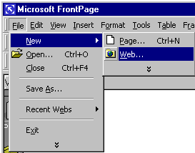
- Go to File>New>Web and left mouse click

You will get a window that will ask you to name your web site and where you want it to be placed
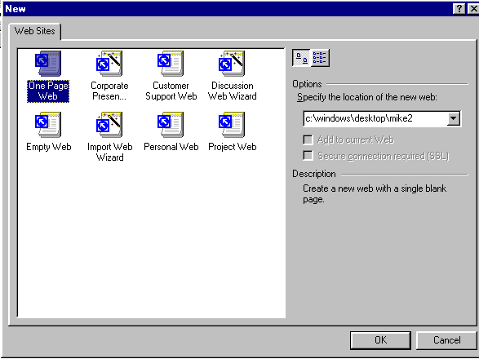
Decide where you area going to save your web page…
…and hit OK

- Once you have done that, you can begin to design your first page. Hit the right Mouse Click and hit “Page Properties”. You will get a screen that looks like this:
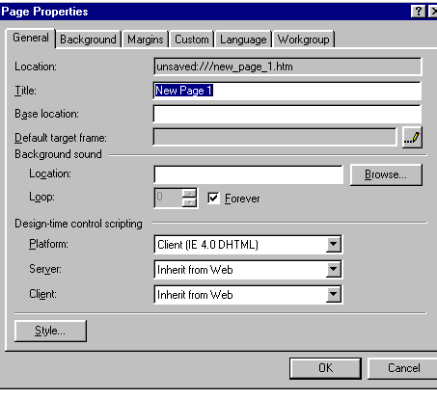
In the box marked “New Page 1” Type in “Home Page” and hit “OK”. Once you have done that, click on the tab marked “Background”. Click on the Colors>Background box and change the color to blue and hit OK. Change the hyperlink to yellow. Hit Save.
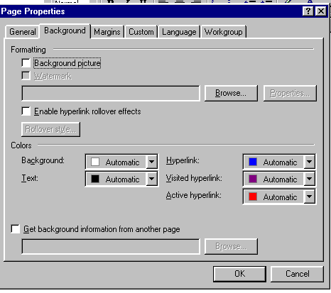
Background color
Hyperlink Color

- On the top of the screen, type “This is my First page. Just like in Microsoft Word, you can select the entire line and center it, make the font bigger and change the color. Center the font, bold it, make it 36 points and make it yellow (to change the color of fonts, see the A icon with the downward triangle.

- Skip two lines. On the third line, “My E-mail address is (fill in your e-mail address). Highlight your E-mail address and press the globe with the chain around it
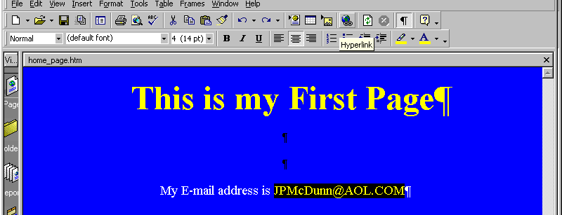

Once you press that button, you will get a screen that looks like this:

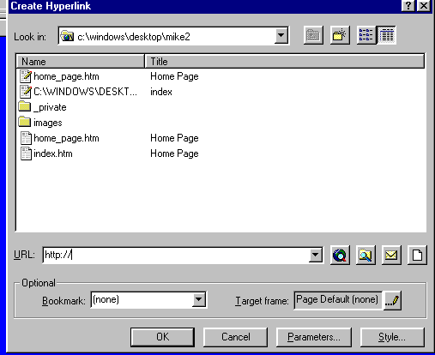
Envelop icon

Press the envelope icon and type in the e-mail address. Hit Save. When the link

been successfully established, the E-mail address will turn yellow.

- Create two more pages by hitting File>New>page and save them by naming them “Second Page” and “Third Page”. Type at the top of each: “This is my second page” and “This is my Third Page”. Either repeat the process for changing the background color and the links color or hit “Get Background color from another page” on the Background folder. Once you check that box, hit the browse button. The page you want to get the background information from is the Home Page. Hit that Icon and it will pick up the information that you previously input.

- At the bottom of The Home Page (the first one you created) type:

Second Page | Third Page

- Highlight the words Second Page and hit the globe with the chain (like you did when you made the e-mail link). On the menu above, you will see “Second Page” and “Third Page” already saved. Hit “Second Page” and hit OK. Hit Save.

- Go to the second page through the Windows menu and type:

Third Page | Home

Link your home page to the word “Home”

- Go to your third page via the Windows menu and type

Second Page | Home

- Link the second page and the home page to the words as previously instructed.

- To create an External link (to Yahoo.com for instance,) type Yahoo.com on the first page and highlight it. Repeat the steps to link it expect type yahoo.com in the URL window. The URL window is the one that already says http://. Once you have done this and saved all of the pages all of the links should work assuming you are on a computer that is on-line.

- On the bottom left hand side of the screen there are three tabs: “Normal” “HTML” and “PREVIEW”. By pressing that tab, your web page will show you how all three links work.

- Now, let’s add a photo. Click on your Home Page. Place your pointer under the Headline (the “This is my Home Page” line). Insert a photo EXACTLY the same way you do it in Word:

- Insert
- Picture
- From File

You will get a screen that looks like this:

Click Here
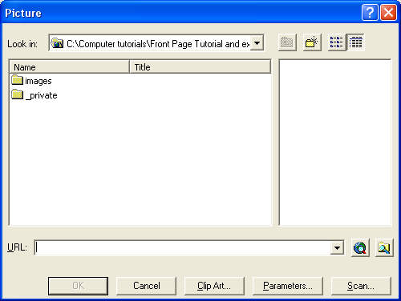
Click on the file with the magnifying glass in the middle. Find your picture and hit OK. Make sure your picture is centered. Your picture should be between your headline (This is my first page) and your e-mail address line.

- Below the “My E-mail address is….” Type “This is what I like to do”. Make sure it is centered.

- Include a table with 2 Rows and 3 Columns.

- Include three pieces of clip art of pictures that represent things that you like to do in each of the top rows. Below write a description of what you like to do. ALL PICTURES AND DESCRIPTIONS should be CENTERED.

Now, we will link clip art photos to your web site

- Go online and find three web sites that reflect what you like to do. Copy their URL into a Word Document.

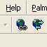
Copy your URL of your first picture. Select that picture then hit the globe with the chain around it
It looks
like this

- Paste the URL that you just copied into the window that says URL (make sure the HTTP:// is not in there twice).

- If you haven’t done so lately THIS WOULD BE A GOOD TIME TO SAVE.

- Repeat that process for the other two pictures. Once you have done that, repeat the process for the caption below the picture. Select the entire caption (you can’t triple click, you have to drag me mouse across the entire caption), hit the globe with the chain and enter the URL. When you return to the Preview Page, you will notice that your captions are underlined, indicating that they are links.

- Go on online and find a picture that you like (Making sure it is SCHOOL APPROPRIATE). Right click on the photo and hit SAVE PICTURE AS. Save it on the desktop with any name that you like. Before you save it, you MUST
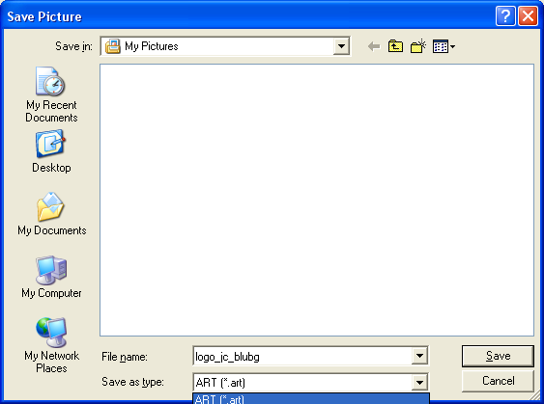
Make sure you TYPE in a .bmp to your file name. It should be bob.bmp
Hit the drop down box and save your picture as a BMP (bitmap file
- Go to the SAVE AS TYPE box and indicate that you wish to save it as a BMP (bitmap) file. Use the drop down arrow to indicate that.
- You MUST put a .bmp in your description name. If you don’t IT WON’T OPEN!

- Design pages two and three any way that you want BUT:

- Each page MUST have something on it other than what was indicated in this tutorial
- You MUST use AT LEAST
- A table
- Bullets (with a least three bullet points listed)
- Numbers (with at least three numbers listed)
- One more picture (you can make it linked if you like)
- One like of type that is linked to a web page
- Have type of DIFFERENT SIZES and DIFFERENT COLORS on at lease one of the pages
- The picture that you saved off of the internet via step 23

- Once you have SAVED your web site to your desktop (and your disk if it will fit), view it in the PREVIEW mode. When you are sure that all of your links work, call me over for a review of your work.

