Unit 1: Introduction

Description of Unit
This lesson introduces you to the wonderful world of relational databases, specifically MS Access 97, and how to tell when Access would be useful to you in your job, business, or in your home. Some useful terms and definitions are included to help you become familiar with the terminology commonly used in Access 97. There is no need to open the Access program at this time but in the next unit - be ready!

Objectives
- Learn about relational databases in general - what it is, how it works.
- Understand when and why you would choose to use MS Access.
- Know basic terminology found within Access.

Administrivia
At the end of each Unit, there is a Project Question and a Project Task (no task in Unit 1). You are encouraged to complete all the exercises, including the additional exercises, and both the Project Question and Task. If you complete each project task, you can have a complete database created by the end of the class.

What is a database?
A database is a collection of data which is organized in a manner that can be easily retrieved. They consist of fields, records, and files, much like a telephone book. A field is a single piece of information (your last name is one field); a record is one complete set of fields (your entry in the telephone book is a record); and a file is a collection of records (the entire telephone book). When you look at the phone book for someone's telephone number, you are the "search engine" for the telephone book database. The only difference is that the search engine included with database programs is probably a little faster than you are at retrieving information.

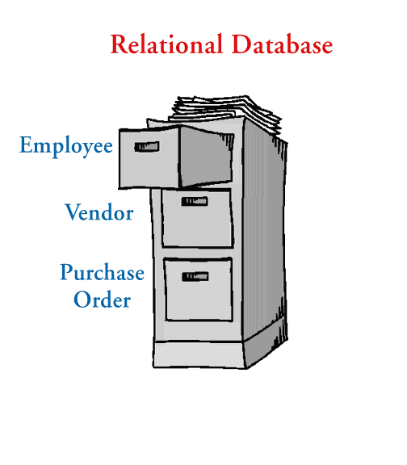What is a Relational Database?
A relational database is a single database spread across multiple tables. Think of a database as a file cabinet and each drawer of the file cabinet is a table.

Example. All of the employee information is kept in the first drawer; all of the vendor information is kept in the second drawer; and all of the purchase orders are kept in the third drawer. To connect each of these drawers (which is what makes it "relational"), a set piece of data from one drawer has to be present in one of the other drawers.

For instance, a purchase order will have a vendor name, address, & phone number on it, along with the items purchased, purchase price, and any discounts. If the vendor name is the "set" piece of data, it is entered in the purchase order table, but the address & phone number are retrieved from the vendor table instead of having to re-type that information each time it is needed in the purchase order table.

When Should I Use Access to Store Data?
Databases, like Access, are used to store large quantities of information. The information can be viewed, sorted, manipulated, retrieved, and printed in various ways. The database gives you the flexibility to obtain this data in multiple formats. If the information you need to store is vast, interrelated, and you need to retrieve it fast & accurately, Access is probably the way to go.

Terms and Definitions
Field
The smallest piece of data in a table.
Cell
Where one row and one column intersect on a table.
Record
A collection of all fields relating to one person, place, or thing (i.e., Cindy Ireland's mailing address) occupying a single row of a table.
Table
A collection of records (i.e., all WSU employee's mailing address information) with one record occupying a single row with one or many fields per row. A database can consist of multiple tables.
Query
Asks specific questions about the data in the database.
Forms
A method of entering, displaying, and searching data in other than the spreadsheet-like environment of tables and queries (a graphical user interface).
Reports
Summarizes and formats data in the "look" that you want for either table or query data.
Object
Components that make up a database (i.e., tables, forms, queries, reports, macros, & modules).

Let's Look At Access 97

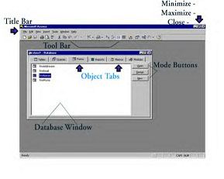 | The Access database window is the initial screen you are given. This is where all objects can be manipulated. As with all Windows 95 programs, you can close, maximize, and minimize your program window by clicking on the icons in the far upper right hand corner  (the X closes). The Title Bar is the area where the program name is displayed - in this case, MS Access. The menu bar is between the Title Bar and the Tool Bar. You can select functions by selecting the options from the various menus. Object Tabs allow you to select the object area you wish to work with (i.e., tables, forms, queries). Mode Buttons include Open, Design, and New -- these allow you to create new objects or edit existing ones. The window where the
objects are located is also call the Database Window.

TIP: Place your pointer on any area of the Access database window and a text box will be displayed describing what that area is called. This is called a screen tip.

Naming Conventions
Consistency when naming the objects in your database is important. The LNC (Leszynski Naming Convention) is the most widely recognized. It states that one should precede each object name with a three letter tag to indicate the type of object. The object name should begin with a capital letter, no underscores or spaces are used.
The logic behind this type of naming convention is ease of use. Also, if you left your current job to accept another job that pays way more money, better benefits, brand new office furniture & computer, and your new boss is absolutely the most wonderful person to work for.....Well, you get the picture, you need to have your Access database setup so anyone could easily use it. Thus, the need to use this naming convention.
For these lessons you will use the following naming conventions. However, you may wish to continue using these conventions for your personal or business use.

Object Name | Access Tag
Table | tbl
Form | frm
Query | qry
Report | rpt
Macro | mcr

As an example, if we create several forms to aid in data entry, we might name the forms: frmEmployee, frmPhone, frmDepts, etc.

Summary
Since it may be difficult for us to reorganize and extract data from the hard copy equivalent of a database (such as a phonebook), we have committed ourselves to learn an electronic form of managing this data. Once we understand what Access is and what it can do for us in our jobs or in our personal lives, we will be motivated to learn, ask questions, and gain knowledge and skills in this area.

There was some terminology introduced in this unit - it is advisable to learn these well as this terminology will be used throughout the lessons. Some reminders of term meanings and naming conventions may or may not be given in subsequent lessons. It is your responsibility to remember and use these correctly.
While some of the information is dry (as with the definitions), we hope to interject insight, understanding, and some humor into these lessons. Next time, we'll open Access 97 and do some exploring! An adventure awaits you....

Exercises
- In your own words, define:
- database
- relational database
- field
- cell
- record
- table
- query
- forms
- reports
- object
- Why use a naming convention when creating database objects?

Unit 2: Designing a Database (Part I)

Project Question
Determine the purpose of the database you want to create. What data will be stored there? Why?

Description of Unit
This lesson introduces you to the process of designing your relational database and then applying your design to an Access database. The terms and definitions learned in the previous Unit will be used a great deal in this Unit. New terminology will be explained as it is used.

Objectives
- Learn to sketch out your database prior to opening Access.
- Learn to create a new Access 97 database.
- Understand the use of multiple tables in your database.
- Create multiple tables.

Designing Your Database
There are specific steps you should follow when designing your database:
- Determine the purpose of your database. This will help you decide what data you want your Access database to store.
- Determine the tables you will need. Once you have a clear purpose for your database, you can divide your information into separate subjects, such as "Employee" or "Orders". Each subject will be a table in your database. Remember your naming conventions from the last unit.
- Determine the fields that you will need in your tables. Decide what specific pieces of information you want to store in each table. Each category of information in table is called a field and is displayed as a column in the table. For example, one field in an Employee table should be Last Name; another could be Hire Date.
- Determine the relationships. Look at each table and decide how the data in one table is related to the data in other tables. Add fields to tables or create new tables to clarify the relationships, as necessary.
- Refine your design. Analyze your design for errors. Create the tables and add a few records of sample data. See if you can get the results you want from your tables. Make adjustments to the design as needed.

Complete these steps using a piece of paper and a pencil. You will probably revise these many times before you have a final design. Experiment with sample data and models of your forms and reports. Make sure the database design stores the data in the manner you need, retrieves the data correctly, and gives you the output (printed document) that you require. It is much more difficult to make changes to the tables, forms, and reports after real data is entered. Double-check your design to make sure it contains all the data you will require BEFORE entering the real data.

Common Design Problems
There are several common pitfalls to keep in mind as you design your database. These problems can cause your data to be harder to use, maintain, and retrieve. The following are signs that you should reevaluate your database design:
- You have one table with a large number of fields that don't all relate to the same subject. For example, one table might contain fields pertaining to your customers as well as fields that contain sales information. Each table should contain data about only one subject.
- You have fields that are intentionally left blank in many records because they aren't applicable to those records. This usually means that the fields belong in another table.
- You have a large number of tables, many of which contain the same fields. For example, you have separate tables for January sales and February sales, or for local customers and remote customer, in which you store the same type of information. Try consolidating all the information pertaining to a single subject in one table. You may also need to add an extra field, for example, to identify the sales date.

Creating a Database
Before we can proceed with this Unit, an explanation of how to create a blank database needs to be given. Open your Access 97 program. Click the Start button - highlight Programs - find your reference to Microsoft Access and click on it. The Access 97 program will start.

Select Blank Database from the window that appears. Select the folder or directory that you want your database saved to and give it a filename. Click Create.

A database window will be displayed. You can also use the Access wizards to create a new database if you wish; however, for these units, we will not be using the database wizard. The Database Wizard creates all objects needed for your database as well as other objects that we will not be using in this workshop. It completely takes over the development of your database so using it in this instance would take the educational value out of these lessons. Also, please do not create any objects until you are given the instruction to do so.
Exercise 1: Create a new Blank Database now. Use the directions in the above paragraph to complete.

Creating Multiple Tables
Exercise 2: Create a table named tblStudents.
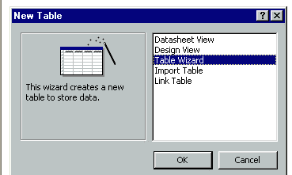
To create a table in a new database, click on the Tables tab in the database window. Click on the New button on the right side of the window. A "New Table" window is displayed.
Select Table Wizard from this list and click OK. [NOTE: the wizard is a quick and easy way to create new objects.]

Select Students from Sample Tables list and then each of the following fields (highlight field and click the arrow that points to the right): StudentID, LastName, FirstName, Major, PhoneNumber, EmailName, and StudentNumber. Highlight StudentNumber and click the RenameField button at the bottom of the field list. Rename it to AdvisorNumber and click OK. Click the Next button to go on.
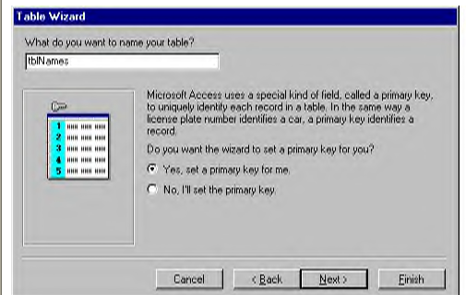
Rename this table to tblStudents and leave the "Yes, sets the primary key for me." from the center of the window. Click Next to proceed. StudentID will be the field that is unique on each record and let Access automatically number this field (is much easier). Click Next.

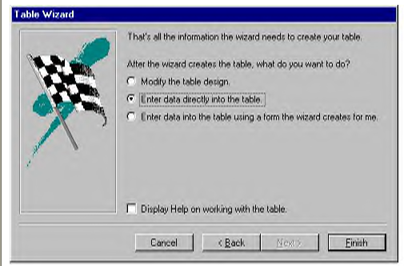
The final screen of this wizard allows you to begin entering data immediately, make design changes to the table, or enter data using a form that the wizard will automatically create. Select "Enter the data into the table using a form the wizard creates for me" and click Finish. Exit the form when it is displayed.
Click on the Form tab, highlight the form that was automatically created, right click on the form name, select Rename from the menu, and rename it frmStudent.

Navigating Tables
There are numerous ways to maneuver through an Access table. If you want to just look through the table without moving the cursor/highlight, use the scroll bar on the right side of the table. However, if you want to move the highlight as you move down the table, you can use the down arrow <Dn> or the page down <PgDn> keys. The same is true if you are moving up the table - use the up arrow <Up> or the page up <PgUp> keys.
If you want to move the highlight to the very first cell of the table (A1), press <Ctrl-Home>. Conversely, if you want to move the highlight to the very last cell of the table, press <Ctrl-End>. To move the highlight from field to field, use either the <Tab> or <Enter> keys.
Additional keystrokes & navigation tips will be discussed when first mentioned in the documentation.

Defining Relationships

Primary Key
Relationships between tables is a vital part of what makes Access 97 work so well. This one point makes a difference between having a bunch of data and having a relational database that helps you be more efficient and effective at your job.
Let's use an example to help clarify the relationship issue. We have information regarding both Students and Advisors in the College of Agriculture & Home Economics. There is related data in these pieces of information because each advisor has students to advise and every student has an advisor. Of course, this database could be one massive table that might contain all the necessary fields:
Student Last Name
Student First Name
Student Major
Student Phone
Student Email
Advisor Last Name
Advisor First Name
Advisor Building/Rm
Advisor Phone
Advisor Email
The difficulties of this approach are fairly obvious. Suppose one advisor works with 20 students. As information on each student is entered, the information for the advisor must also be entered. Entering the exact same information is tedious work to say the least. Remember: You should only enter any one piece of data ONCE. So, instead of entering the same advisor information for each of the 20 students, let's separate the data into two different tables with a relationship established.
Advisor Table
Last Name
First Name
Building/Rm
Phone
Email
Student Table
Last Name
First Name
Major
Phone
Email

So, how do we identify which students belong to which advisor? We would use a Primary Key. A Primary Key is a unique record identifier in each table. In our Advisor/Student database example above, there is no field that can be used as a Primary Key. Last name for either table is not a good choice - we could have duplicates for different individuals. First name in either table is not a possibility for the same reason - duplicates are possible. Address, phone, and email are not good choices because there can be duplicates but more importantly, they can change. Any field that can change is not a good choice for the Primary Key. The Primary Key should stay the same from the very beginning.

A standard, traditional database practice is to assign an ID number to each record. Access 97 provides us with AutoNumber. This is an integer that is incremented with each new record; the first record has an ID of 1, the next has an ID of 2, etc. Our ID field in each table becomes the Primary Key, the unique identifier for each record. This number stays the same regardless of how it is sorted or queried or printed. It is a static field.

Relationships
Now we need to look at how these two tables are related, how exactly advisors are related to students. Each student has one advisor but each advisor can have many students. This is called One-To-Many Relationship. Wow, something that makes sense!
The basic rule for establishing a One-To-Many Relationship is: make the table with the many point to the table with the one. In our example, Student is the table with many (remember, one advisor has many students) so we want to add a field to the Student table that points to the Advisor table. The new field we create needs to point to the Primary Key (ID) of the Advisor table. The Advisor ID field in the Student table, since it refers to the Primary Key of another table, is known as a Foreign Key. The Foreign Key must be the same field type (Number) as the Primary Key.

The easiest way to set a primary key is to let Access set it for you in the Table Wizard.

Summary
In this unit you have created a new database and two new tables. You've learned that the object wizards (i.e., Table Wizard) are helpful in developing objects for your database. You've also learned the foundation for understanding relationships between tables. We will use this information in a later lesson so make sure it is clear to you.
The next unit will continue using the database & tables we created in this Unit, so make sure you save your database before exiting (File - Save).

A table name can be up to 64 characters including letters, numbers, and spaces. Creating meaningful names for all objects [remembering the naming convention from the previous chapter] will help to make it easier to use and manage.

Exercises
- Define Primary Key.
- Define Foreign Key.
- Define a "relationship" between two or more tables.
- Review the process of creating a new database & table. Practice navigating around a table using the mouse & Access buttons as well as the directional keys.

Project Question
Determine, on paper, the tables you will need for your database. Your purpose was defined in the previous Unit - divide your information into subjects. Each subject will be a table in your database.

Unit 3: Designing a Database (Part II)

Description of Unit
This unit is a continuation of Unit 2 and will include creating a table from scratch, creating a form, entering data into a table and using a form, and creating a relationship between two tables. You will use the database that you created in the previous unit. Please open Access 97 and the database now.

Objectives
- Learn to create a table from scratch.
- Learn to a create a form.
- Become familiar with entering data into a table and a form.
- Create a logical relationship between tblStudent and tblAdvisor.
- Set Primary Keys & Foreign Key in tables.

Creating a Table from Scratch
In order to gain much more control over the development of a database table, you can create it from scratch using Design View. In Design View, you enter your own field names, descriptions, and choose your own data type to associate with each field. You also set your own Primary Key.
Before creating a table entirely from scratch, you should write down your basic table structure on paper, focusing particularly on field names and data types. Access fields can have one of the following data types:

Data Types | Definition
Text | Stores text or combinations of text and numbers (i.e., addresses) up to 255 characters.
Memo | Stores text and numbers with up to 64,000 characters; used for detailed, descriptive fields.
Number | Stores numeric data that you can use in calculations.
Date/Time | Stores a field in date or time format.
Currency | Stores currency data that you can use in calculations.
AutoNumber | Stores a sequential number for each record.
Yes/No | Stores only one of two values such as Yes/No, True/False, or On/Off.
OLE Object | Stores objects created in another application, such as Word 97 or Excel 97, that you can link to or embed in an Access table.
Hyperlink | Stores a link to a URL.
Lookup Wizard | Stores a lookup column that you can use as a lookup in another table.

While it will not be necessary for you to know all of these data types it is a good idea to have a general knowledge of the possibilities in defining the data fields.
Exercise 1: Create a new table from scratch.
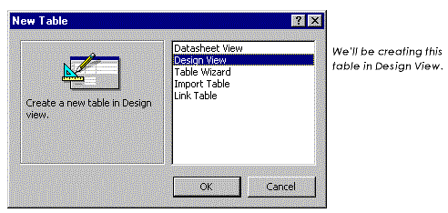
Click on the Tables tab in the Database Window. Click on the New button; a New Table dialog box opens. Click on the Design View option and click OK.
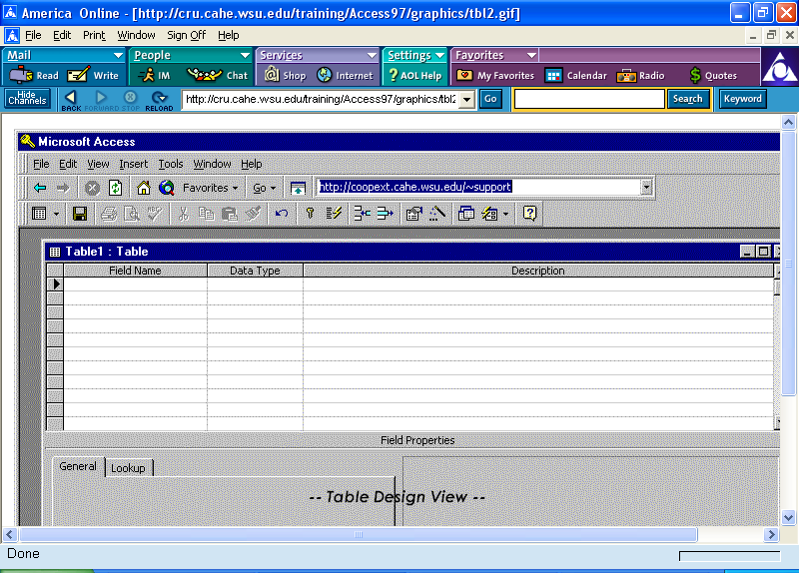
A blank table will open in Degign View
Type ID in the first Field Name column, press <Tab> to go to the Data Type column. [Text automatically appears in the Data Type field as soon as you press the <Tab> key but you can select from any of the 11 options on the list.] Click the down arrow to the right of the field & select AutoNumber from the list. <Tab> to the Description column & type in a brief description of this field (i.e., Advisor Last Name, Advisor Office Phone).

Repeat the steps in the above paragraph for each of the following field names, all are Text data types: LastName, FirstName, Address, PhoneNumber, and EmailName. When you are finished, your screen should look similar to this picture.

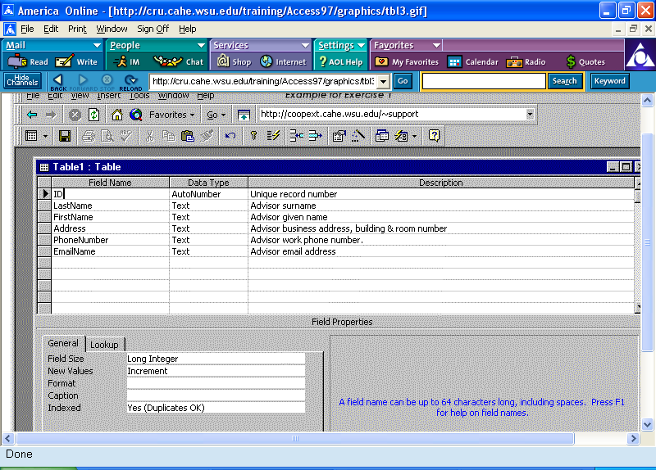

Exercise 2: Set a Primary Key
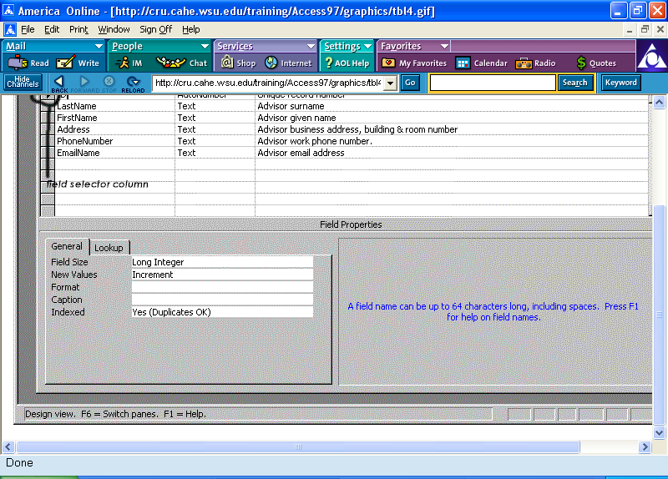
Click on the ID field. [Remember, Primary Key is a field that is unique in each record of the table.] An arrow will appear in the field selector column (far left). Click the Primary Key button on the menu bar. The arrow in the field selector column will turn into a key symbol. This is a toggle field so if you need to remove the primary key from this field, select the primary key field and click the Primary Key button on the toolbar again.

Exercise 3: Set Format Properties
Access 97 always sets each field with the default format for its data type. This format defines how the field displays in tables, forms, and reports. You may want to change this format to one of the other options. For example, a date/time data type can be changed to display long (Tuesday, July 7, 1998) or short (7/7/98).
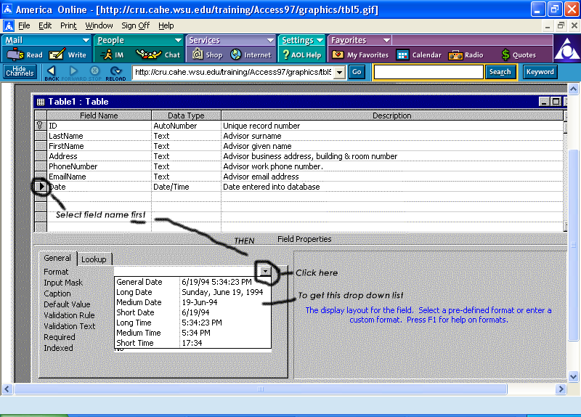
In Design View, add a new field (Date) to the existing table. The Data Type should be Date/Time. Make sure this field name is selected (the arrow should be displayed in the field selector column). The General tab should be displayed below. Click on the Format field. A down arrow is displayed at the right edge of that field, click on the arrow. A list of possible formats is displayed. Select the format of your choosing.

Exercise 4: Set Field Size Properties for Text Fields
The default field size for a text field is 50 characters. You can change this size to any amount from 0 to 255 characters.
Click the field selector column of the field name you wish to change. Click the General tab in the Field Properties. Enter the new field size in the Field Size text box. See picture below.
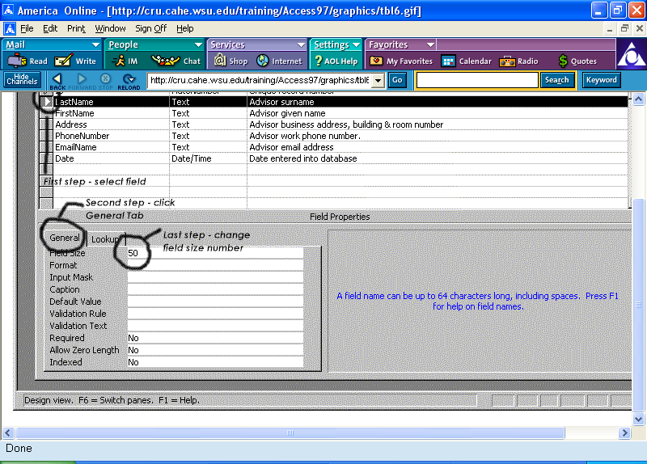
Save your table [File-Save] as tblAdvisors.

Entering Data
There are a couple of notes of interest before you begin the next group of exercises. Telephone number fields will include the area code parentheses when using the wizard - not a huge deal.
Exercise 5: Enter Advisor Data
Enter the following information directly into the tblAdvisor previously created. Notice that you can use the <Tab> or <Enter> keys to move from field to field. Use the arrow keys to move around the table fields as well.
Joe Smith, 423 Hulbert, 335-1111, joe_smith@xwsu.edu
Jane Zane, 211 Food Science, 335-7777, jane_zane@xwsu.edu
Bryan Brown, 333 Clark, 335-6666, bryan_brown@xwsu.edu
Access will create an ID number automatically for each of these records as you create them. Do NOT type a number in the ID field, it contains the words (AutoNumber). After you have entered the above data, close the table. Save and close the table.
Exercise 6: Enter Student Data
Now enter the following data using the form, frmStudent. Find the Advisor number from the table above and enter that, not the advisor's name, in the Advisor ID field.
Shawna Davis, 335-7676, Ag Econ, sdavis@stu.wsu.edu, Joe Smith (advisor)
Jerry Turner, 333-2222, Food Science, jturner@stu.wsu.edu, Bryan Brown (advisor)
Sherry Vineyard, 333-1111, Natural Resources, vineyard@stu.wsu.edu, Jane Zane (advisor)
Deke Einstein, 335-7799, Ag Econ, einstein@stu.wsu.edu, Joe Smith (advisor)
Jay Terry, 333-0000, Natural Resources, jterry@stu.wsu.edu, Jane Zane (advisor)
Save and close the table.

Creating a Relationship
In order to create the relationship between the two tables in our example, you need to identify the primary key and the foreign key.
Exercise 7: Set the Foreign Key
The Primary Key concept was discussed in detail in Unit 2 (review it if necessary). You have allowed Access to set your Primary Key (Unit 2: Exercise 2) and you have set the Primary Key on your own (Unit 3: Exercise 2).
The Foreign Key in the tblStudent table must be the same data type (Number) as the Primary Key in the tblAdvisor because that is the link between the two tables. To check this, from the database window, highlight tblAdvisor and click the Design button.
The ID field is highlighted. The data type is "AutoNumber" and the Field Size is "long integer". Find those two fields. Close this window.
Highlight the tblStudents from the database window and click the Design button. Highlight the AdvisorNumber field. Click the Data Type in the AdvisorNumber field and a pull-down arrow appears. Click on that arrow and select "number" from the list; "long integer" should appear in the Field Size field automatically. This step MUST be completed before progressing to Exercise 8.
In some database programs, this is sufficient - defining the Primary and Foreign Keys. But with Access, we have to specifically define the relation between these tables.
Exercise 8: Create a relationship between tblStudent and tblAdvisor
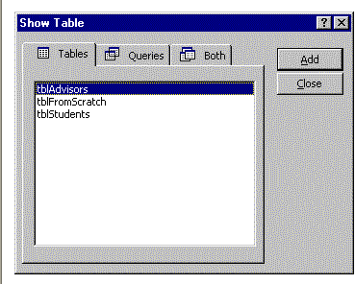
From the Tools menu, select Relationship. A "Show Table" window is displayed. Add the tblAdvisor and tblStudent to the Relationships screen and close the window. Two lists are displayed - each containing the field names in each of the tables.
To actually join the two tables, use the mouse and click the ID field in the Advisory table (our Primary Key). While holding down the mouse button, move the cursor over to the Advisory Number field (our Foreign Key) in the Student table list.

A "Relationships" window is displayed (NOTE: If you click on the "Tables aren't related" option, you can undo a table relationship you previously made.)You'll notice that under Relationship Type that One-To-Many is already selected. Also, check the Enforce Referential Integrity to insure that data entered in the Student Advisor ID field can not be a value that does not exist in the Advisor table. Click the Create button.

After the relationship is created, the Relationships screen shows a connection between the Primary Key and Foreign Key fields. Notice that the Advisor table has a 1 while the Student table has an infinity sign. Together, this signifies the One-To-Many relationship.
Save and Close. Exit the database.
Now that the relationships are defined, it is easy to begin creating queries, forms, and reports.

Summary
In this unit, you have created a new table from scratch and a new form. You have also created the link between your two tables that make your database a "relational database". You are gaining marketable skills every minute you work through this course! You should feel confident in your skills with these tasks. If you are not, please return to the beginning of this unit, re-read the entire document, and complete the exercises again.

Additional Exercises
- I think that is enough work for one week - whew!

Project Question
Determine the fields for each of your tables. Decide the specific pieces of information that you will store in each table. Each category of information is a field. Refer to Unit 2 if you require further information.

Project Task
Create the tables you determined as necessary in the Unit 2: Project Question in your Project database. Use the fields you determined necessary in the above Project Question.

Unit 4: Wizards & Templates

Description of Unit
While you have had some exposure to the wonderful world of wizards in previous lessons, you will be traversing into a deeper understanding & knowledge of how useful wizards and templates can be in your day-to-day operation of Access 97. Creating all the Access objects (tables, queries, reports, forms) is made easy when you use the appropriate wizards. There are multiple types of templates available in Access for your use.

Objectives
- Learn how wizards can make quick work of designing objects.
- Learn to modify the wizards' work.
- Learn how to change the default template.

Using the Wizards
You have already used the wizards to create Tables and Forms in previous units. Most of the wizards are fairly similar in their operation with some obvious differences in regards to specific information. The Wizards will walk you through the basic process of creating an object without you having to know the exact steps. They can make working with Access 97 much easier, especially for the novice.
Suppose we want to build a form so we see the student information listed once along with the advisor assigned to that student.

Exercise 1: Create a form & subform.

1) To create a new form, click the Form tab in the Database window, then click the NEW button.
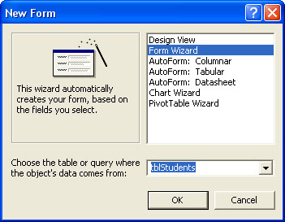 | - From this screen, select Form Wizard. Then, select the Student table from the “Choose the table or query where the object’s data come from” drop-down box.
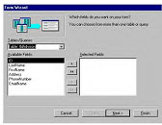 | - The first question the Wizard asks is: Which fields do you want on your form? Select all the fields from the Student table [A quick tip: the double arrows take everything from one side to the side where the arrows are pointing.].  Once the fields from the student table are in place, select the Advisor table from the “Tables/Queries” drop down box. Select all of the Advisor fields by double clicking on the two arrows.
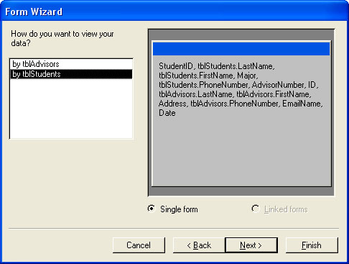 | - The Form Wizard will ask us how we want to view our data. Since we selected Student it will default to that option. However, we could change our table to Advisors if we want to.  Since our needs require us to have a Student table, we will simply select Next.
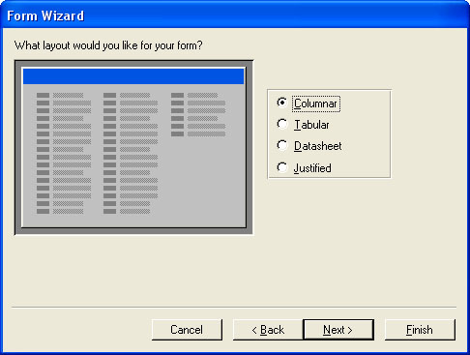 | 5) The next question the Wizard asks is: How do you want to view your data. Select Columnar.
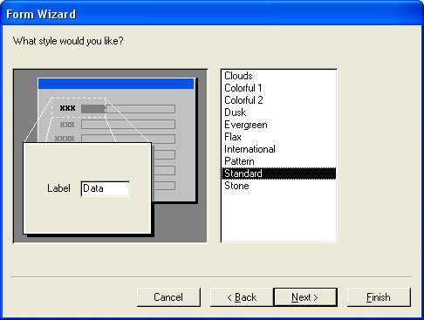 | - Under “What style would you like?”, select Standard
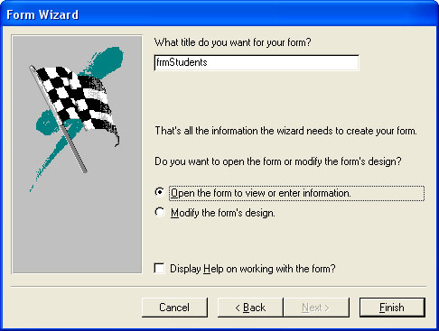 | 7) Finally, it will ask you “What title do you want for your form”. Name it “frmStudent”. .
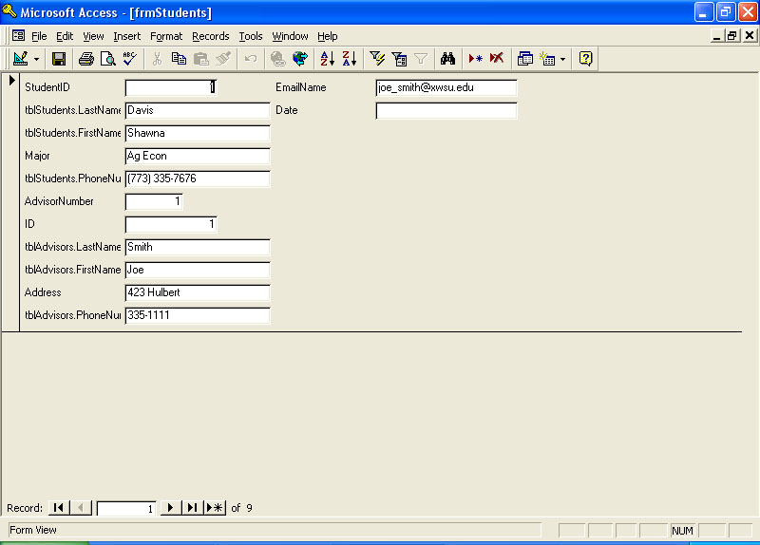 | Access has a great feature at the bottom of the form screen, it is a record number bar that allows you go to the next record, the first record, the last record, or any specific record you choose. The arrow keys take you to (from left to right) the first record, the previous record, the number field where you can type in a specific record number & press <Enter> to move to that record above, the next record, the last record, & the * creates a new record.

Making Changes
After creating an object using a wizard, you may find that you need to make a change, either minor or major. Access allows us to edit the objects that are created with the Wizard.

Exercise 2: Modify Object
Part A: Change the name of the form we just created to frmAdv/Stu and change the name of the Student subform to frmStuSubform. [To rename an object, right click on the object name, and select Rename from the pop-up menu.] Now when you open the Adv/Stu form you get an error that says it can't find the old form name -- major problem!
First thing you have to do is to edit the part of the frmAdv/Stu that points to the old student subform name. To do this, highlight the frmAdv/Stu from the database window, Form tab. Click the Design mode button on the right. The same error about not finding the student subform is displayed - click the button to continue. Inside the inset subform is the name of the subform form. Click the cursor on that name and change it to the correct form name (frmStuSubform). Click File - Save.

Part B: While still in Design mode, you can also change the field labels (aka captions). Click once on the field label to select it, right click to access the pop-up menu, and select Properties. The Caption field is the second item, double-click on it and change it to a caption of your choice. Click the X in the upper right corner of the dialog box to close. Your change will immediately be displayed on your form.
Using Templates

When you create a form or report without using a wizard, Microsoft Access uses a template to define the default characteristics of the form or report. The template determines which sections a form or report will have and defines each section's dimensions. The template also contains all the default property settings for the form or report and its sections and controls.
The default templates for forms and reports are called Normal. However, you can use any existing form or report as a template. You can also create a form or report to use only as a template.
Specify a new template for forms and reports:
- On the Tools menu, click Options.
- Click the Forms/Reports tab.
- Type the name of the new template in the Form Template or Report Template box. Note: You can use an existing form or report as a template, or you can create a form or report specifically for use as a template.
- Click OK.
Notes
- Changing the template doesn't have any effect on existing forms or reports.
- A template doesn't create controls on a new form or report.
- Microsoft Access saves the settings for the Form Template and Report Template options in your Microsoft Access workgroup information file, not in your user database (the .mdb file). When you change an option setting, the change applies to any database you open or create. To see the name of the template that is currently used for new forms or reports, click Options on the Tools menu, and then click the Forms/Reports tab.
- To use your templates in other databases, copy or export the templates to them. If your templates are not in a database, Microsoft Access uses the Normal template for any new forms and reports you create. However, the names of your templates appear in the Form Template and Report Template options in every database in your database system, even if the templates are not in every database.

Summary
You have created a new form with the Form Wizard and see how a subform can be useful to you. The other Wizards generally operate in the same manner; but including speicific details for that particular object.

Exercises
- Create a report using the Report Wizard.
- Use Simple Query Wizard to create a query of all advisors - name it qryAdvisors.
- What can Wizards, in general, do to help you?
- What is a subform?
- What do you do in Design mode?
- How can saving your database as an HTML file help you?
- Save at least one of each object to an HTML web site (using the Save As HTML menu option).

Project Question
Determine relationship(s) that should exist between your project tables.

Project Task
Create the relationship(s) that you determined in the Project Question above.

Unit 5: Query and Reports

Description of Unit
This unit will focus specifically on creating and revising queries and reports. The previous lessons have dealt with planning and constructing your database, and entering data. We will now create the vehicles that will output your data into a usable format by way of queries and reports. Queries are the questions (the query results are the answers). Reports are an effective way of presenting your data (from tables or queries) in a printed format.

Objectives
- Create a query from scratch (no wizards).
- Learn the importance and usefulness of the Datasheet View.
- Revise existing queries.
- Create and revise a report.

What Is A Query?
A query is the question you ask, such as "Who are the students that Bryan Brown advises?", not the results (i.e., Jerry Turner). You may have several queries created as they may ask different specific questions. Once you have created a query, you can run it as often as needed because the results will change each time the table data is changed.
When you begin to design your queries, ask yourself:
- What specific question do I want to answer?
- What pieces of data (fields) do I need displayed?
- What sort order will help me the most?

Datasheet View Explained
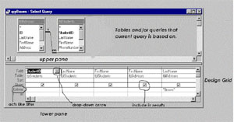 | The Datasheet View is where you design and revise your queries. It allows you to select which tables and/or queries you will use in the Query (upper pane). You can also select the fields to use in the results or in filtering specific records to include or exclude, and how the results are sorted (by which field).

Exercise 1: Create a New Query
- From the Query tab of the Database Window, click the New button.
- From the New Query dialog box, select Design View and click OK.
- From the Show Table dialog box, select tblAdvisors from the Table tab, click Add button. Select tblStudents and click Add button again. Then click Close button.
- Select the following fields to include in the query. Remember that the fields appear in the same order in the design grid as they will in the result. Drag field name from upper pane to lower pane or click in blank field box (lower pane), click the drop-down arrow to see all possibilities, select appropriate field.
*Advisor First & Last Name
*Advisor Email
*Student First & Last Name
*Student Major
- Decide to include all field in results (click Show box to display).
- Select File - Save and name it qryClass - click OK.
- Run (click the ! button in the toolbar). Results are displayed in Datasheet View.
- You can print the results at this point. Click the X in the upper right corner of the results screen to exit.

Controlling the Order of Records (Sorting)
Sorting records based on the contents of one or more fields can make reviewing and editing easier (i.e., alphabetical order by student name). By controlling the order that records are displayed and/or printed, you can create a document that would be helpful to you, your boss, or your clients.

Exercise 2: Sorting | 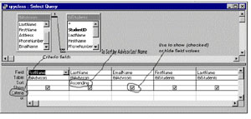

- To add a sort to your query, click the Query tab from the Database Window, highlight the query you wish to add the sort to, and click the Design mode button on the right.
- In the lower pane, click on the sort box of the field (Advisor Last Name) you wish to sort by.
- Click the drop-down arrow to see the list of sort options. Select Ascending from the list.
- Run the query (click the ! in the toolbar). Note the differences in how the data is displayed.

Include Only Specific Records
"Criteria" acts like a filter - it filters out certain records and lets others through (the ones that meet the criteria stipulations). If you want to limit the results of your query, you can set up a specific criteria. If the record meets that criteria, it is included in the results. For example, if you only wanted the records for the advisor, Jane Zane, you can set the Criteria on the Advisor Last Name column to Zane. Only the records with Jane Zane will be displayed in the results.
Exercise 3: Using Criteria to Select Records
- Return to the Design View of your query.
- In the Advisor Last Name column, click on the Criteria field & type Brown.
- Run the query.
- Save this query.

Save the Query
Remember that when you save a query, you are saving the question, NOT the answer (or result). While in the Design View of your query, click the File menu option. Select Save from the menu. OR, click the diskette icon on the toolbar to save.

Creating & Revising Reports
You can create new reports based on one or more queries or tables. A report is a way for you to display data from a query and/or table in an appealing way (i.e., for a presentation). Using the Report Wizard is a great way to create a basic report but to revise it, let's walk through an example.
Exercise 4: Create New Report
- From the Report tab, click the New mode button.
- Select Report Wizard, select tblAdvisors (click the down arrow on the right of the blank field), and click OK.
- Select all fields from the tblAdvisors and the tblStudents tables (remember to use the double arrows to move all the fields over at once). Click Next.
- Answer the question "How do you want to view your data" by leaving it at the default and just clicking the Next button.
- Answer the question "Do you want to add any grouping levels" by leaving this dialog box at its defaults. Click Next.
- Sort by student last name. Click Next.
- Leave layout dialog at its defaults but change it to Landscape instead of Portrait & click Next to continue.
- Select Casual for the title style and click Next.
- Change the report name to rptStuAdv and click Finish.
Don't worry about how your report displays at this point. It contains a lot more information than you would probably include in any one report.
Exercise 5: Revising an Existing Report
- Click on the Report tab and highlight the rptStuAdv report.
- Click the Design mode button on the right.
3) The Design View of the existing report will be displayed. | 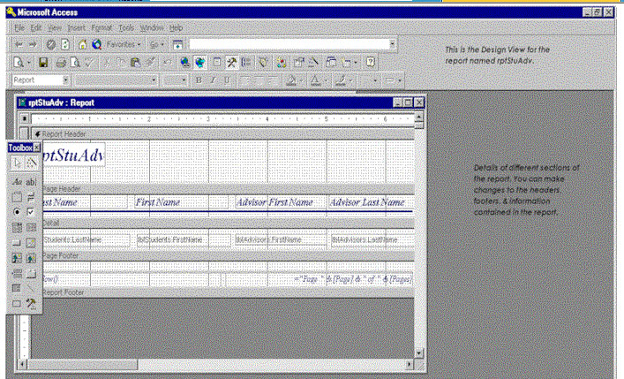

4) Highlight the text in the Report Header and replace it with Students and Advisors '98. Right click on the Report Header field and select Properties from the list. (If right click doesn't give you a menu, click off of the Report Header and then try again.)
5) Take the slider and move it to the bottom of the Label property dialog box. Under Text Align, click your cursor, click on the pull-down arrow, and select Center from the choices. | 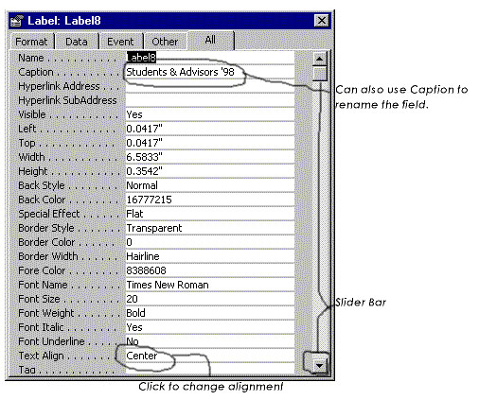
6) Select the Report Header field (black boxes along edge show it is selected) and drag the box, using the right center box, to the right edge of the design, and let go of the mouse button. Your title should be centered over the text fields now. | 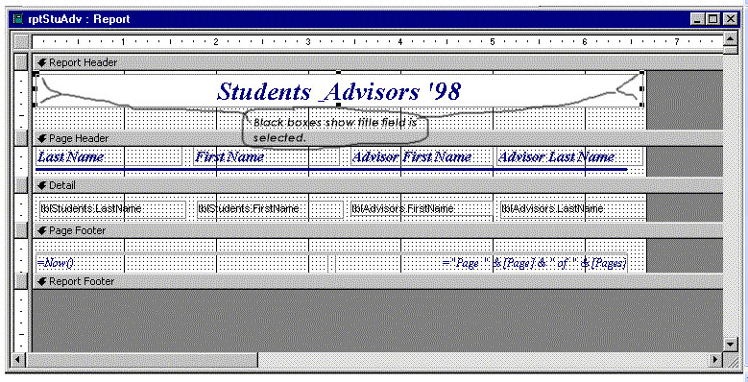

7) Select File-Save and save the report under the same name (rptStuAdv).

Summary
There are many other functions of the Query & Reports features that may be useful to you in your current and/or future position(s); however, there is not enough time to delve into all the areas. The best advise is to keep learning, experimenting, and researching. When you need to learn another feature or function of Access 97, find a good resource (on the Internet or in a hardcopy manual) and use it to find your answer.

Additional Exercises
- Create a Query without using the Query Wizard that will include Advisor email, Last Name, and the student's full name & major. Sort by student's last name and include all field data.
- What situation might you create a Report from a Query?

Project Question
Determine what your data output needs are for your project. What type of reports do you need? Which fields of data must be included in the query? Which fields of data need to be included in the results?

Project Task
Make necessary changes to your database and objects that you determined necessary in the Project Question above. Create at least one report using Report Wizard. Enter test data (2 or 3 records per table) to test the report output.

Unit 6: Shortcuts, Tips & Other Fun Stuff

Description of Unit
Our last unit of this workshop should be tons of fun. So I have done some extensive research to find some shortcuts, tips, tricks, and anything else I could find that will make using Access 97 on a daily basis more fun and less like work. So hold on for some great information that you may want to keep close to your computer and share with others who are using Access!.

Objectives
- Discover some shortcuts to using Access 97 that will make your life easier and more efficient.
- Items to help manage your time better.
- Fun stuff that you may want to share with others.

Keyboard Shortcuts
- When adding or changing date-oriented records, hold down the <Ctrl> and semicolon keys <Ctrl-;> to insert the current date. <Ctrl-:> [Ctrl key + the colon key] will insert the current time. [NOTE: If the date and/or time are incorrect, check the date & time settings on your computer, they are probably wrong.]
- Hold down the <Ctrl> key and tap the plus key <Ctrl-+> to add a new record to the current table. <Ctrl--> [Ctrl key + the minus key] deletes a record. Although deleting records that are used in a related table is not allowed.
- To copy a field's value from the previous record to the current record, press <Ctrl-'> [the Ctrl key + the apostrophe key].
- To quickly use a field's default value (if there is a default value set), click the field then press <Ctrl-Alt-SpaceBar>.
- To save instantly, press <Shift-Enter>.
- When you are filling in check boxes & option buttons, press <Tab> to highlight, then press <SpaceBar> to toggle the control on & off.

Offer status bar suggestions
No matter how easy a task, it always seems that people can use a little help along the way. That's why Microsoft displays so many helpful notes in the status bar along the bottom of the screen. Access 97 puts this technology in your hands with the Status Bar Text property. To include your own Status Bar message for a field, button, or other control on a form:
- Open the form in Design View.
- Right-click the item you want to work with, then select Properties from the pop-up menu.
- When the Properties dialog box appears, click the Other tab.
- Enter your message into the Status Bar Text area.
- Close the dialog box, and save your form.

Tips
- Include live URLs in tables. Access 97 introduces a new field type that's custom-made for Internet and intranet applications. The Hyperlink field supports standard URL formats, so it can hold email addresses, as well as links to Web pages, gopher and FTP sites, and newsgroups. Even better, because Hyperlink fields are live, users simply click them to go to the proper location.
With the Hyperlink field in your table-building arsenal, you can build Internet- or intranet-linked databases for competitive intelligence (your competition's Web sites, newsgroups where customers congregate, and similar items), employee information (cataloging documents available through your intranet and tracking updates), and so on.
To learn more about building URLs into your tables, click the Office Assistant, and search for hyperlink fields.
- Use the Office Assistant to answer questions, give you more tips, and entertain you while you are working in the application.
- Right-click your way to happiness. Microsoft has adjusted the menus that pop up when you right-click an object in a database. Although the changes aren't huge, they do make Access 97 easier to use. Look for new items (such as the Filter For option when you right-click a field in Table View) and helpful icons (see the Form Design View pop-up that appears when you right-click the form itself) scattered throughout the pop-up menus.

Automatic Report & Form Builder
Try using the automatic wizards when you need a quick form or report for a single table:
- From the database window, select the appropriate tab (Reports or Forms).
- Click the New button.
- Select Auto Wizard from the list (either AutoReport: Columnar, AutoReport: Tabular, AutoForm: Columnar, AutoForm: Tabular, or AutoForm: Datasheet).
- Select the table on which to base your form or report from the drop-down menu.
- Click OK to activate the Wizard. When finished, the wizard displays the finished object.
- Remember to save the object before exiting.

Sharing Data
Access 97 allows you to share data between Access and Word & Excel. Click the button "Office Links" on the toolbar to access this powerful feature. You can Merge it with MS Word, Publish it with MS Word, and Analyze with MS Excel with a click of a button. Highlight an object name in the Database Window & click the button. The options that are available to you will be in dark print. Highlight the one you want & you will be amazed at the ease of creating other documents. The Merge with MS Word is done with a wizard so it is also a painless method of using the data in Access to merge with a Word document.

Instant Tables
If you are in a hurry, you can get your data entered into a new table very quickly. Click the Tables tab in the Database Window and click the New button. Then select the Datasheet View in the New Table dialog box, click OK. A blank table is automatically created and you can begin your data entry.

Add Reminders
Screen Tips (Tool Tips) are those little bits of text that popup when you point the mouse at a button or menu item. You can attach these helpful items to fields, buttons & other items on your forms to help you (or others) enter data faster and more consistently:
- From the Form tab, select the form you want to work with, press the Design mode button to access the Design View. Right-click the item you want to work with (field, button, etc.).
- From the popup menu, select Properties to open the dialog box.
- Click the Other tab, then type your Tool Tip text in the ControlTip Text field.
- Close the box and save the form.

Exercises
Experiment with some of the tips and tricks in this lesson. Decide which ones you will use consistently and which you want to file away for use periodically.

Project Question
Critique your database. Do you have a table with a large number of fields? Do you have many records with blank fields? Do you have a large number of tables containing the same fields? If yes, go back to Unit 2 "Design Problems" and decide what you can do to make your database more efficient and better designed.

Project Task
Make necessary design changes per determination above. Create a query (use of wizard okay). Enter at least 10 but no more than 20 records in each table. Test your queries & reports to make sure they give you the output you desire.

Congratulations! You've completed your Beginning Access 97 project.

http://cru.cahe.wsu.edu/training/Access97/

